Wolfson Paper - Final

Thank you all very much for coming this evening – and thank you to John and Wolfson College for hosting.

It’s a tremendous pleasure to be on the stage with these eminent gentlemen and I know they’ll have plenty to say about what has been an unprecedented election cycle.

When John and I first talked about doing this seminar back in the spring we were as staggered as everyone else watching each new development in the Trump campaign and wondering where it might eventually end up – or if truth be told, wondering what exactly it would take for it all to implode…

But we knew – as I think all of us did – that however this election turned out, the nature of the campaign meant it was going to be hugely significant, both for journalism and democracy.

It seems we’re having our most trivial election ever at a time when the issues we face are the most complex.

Media, politicians, even citizens themselves – all of those groups are in part responsible for that, and together maybe we can explore some of the reasons why this evening.

The first Presidential campaign I wrote about was in 1988, between George H W Bush and Michael Dukakis – seems such a long.. long time ago – and obviously even then there were echoes of nastiness in things like the Willie Horton ad, used to heighten racial insecurities – but what’s happened over the past couple of weeks in this campaign makes Mitt Romney’s “binders full of women” comment from the 2012 cycle seem positively quaint.

When we talk about a “post-truth” environment we don’t just mean, I think, simply that politicians lie – sadly that’s nothing new and it’s certainly not specific to this particular context. But I think where the Trump campaign has re-defined the notion of “post-Truth” is in the fact that those lies no longer appear to have real consequences.

We have a candidate who makes outlandish and absurd claims, quotes randomly made-up statistics that bear little relation to fact, never apologizes or corrects, and yet continued to ride out a series of gaffes that would have spelt an embarrassing end for a “normal” candidate on his way to the nomination of a major party.

And his words certainly seemed to have no consequence in terms of the loyalty of his core support – as he said himself: “I could shoot someone on Fifth Avenue and not lose any votes.”

As dog-whistles became foghorns, it was almost as if, the more outlandish and anti-establishment his rhetoric, the more his base rallied to his side.

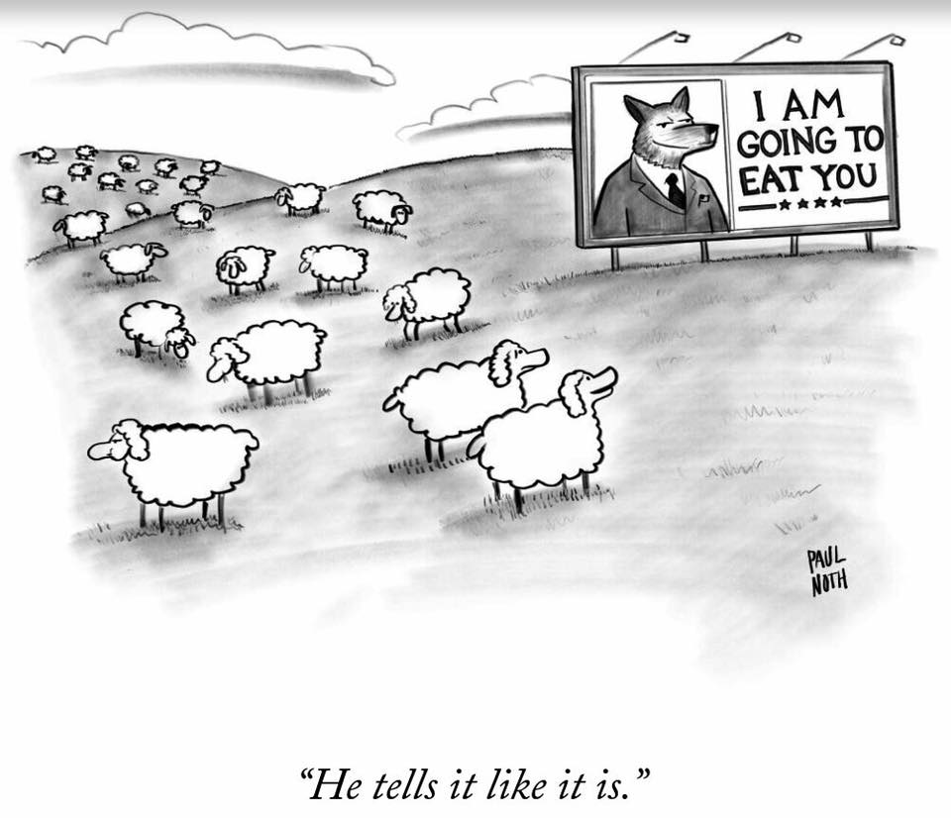

So I ‘m going to try to keep my observations about the media simple tonight and break them down into two questions – How did we get here? And where are we going?

There was a symbiotic relationship between Donald Trump and the press almost from the moment he rode down the golden escalator at the Trump Tower in June 2015 and declared that Mexicans were rapists “although some of them, I’m sure, are good people.”

For online news sites, both those that were part of legacy brands and those that were standalone ventures, Trump’s controversial statements and the polarizing reaction to them meant he would quickly become clickbait personified.

And what’s more, he came along pretty much exactly when a revenue-challenged media industry needed him.

For the TV networks, ratings went through the roof — along with their ad rates. The “Trump effect” drove bigger audiences for election coverage in general and, in particular, record ratings for the string of Republican primary debates, with networks able to charge well into six-digits for a 30-second ad spot in key debate broadcasts.

So it’s probably no surprise to learn this week that CNN’s earnings in TV and digital are set to be $100m above expected for this year.

“It may not be good for America, but it's damn good for CBS… Sorry. It's a terrible thing to say. But, bring it on, Donald. Keep going.”

- Les Moonves, CEO, CBS; speaking to an investor conference, Feb 2016

It wasn’t just CBS, of course. As the bandwagon kept rolling, all the TV networks were in thrall, and as a result, provided Trump with an estimated $2billion worth of free airtime during his primary campaign.

Someone wrote at the time that CNN was covering Trump as if he was a missing plane.

The downside for TV was that the Trump campaign was hardly spending anything on ads – but that was more than made up for by the rest of the large primary field. Jeb Bush, for example, in what the New York Times called “one of the least successful campaign spending binges in history” spent $84million on ads, part of a total spend of around $130million before dropping out.

And the expectation was that ad revenues would also ramp up during a competitive general election campaign.

“All Trump All the Time” was the perfect candidate for the dumbed-down, short-attention-span, soundbite, reality show culture our politics has become - a larger than life, unpredictable personality who, even when he had nothing to say, would call a press conference and have live TV coverage of an empty podium for an hour before showing up.

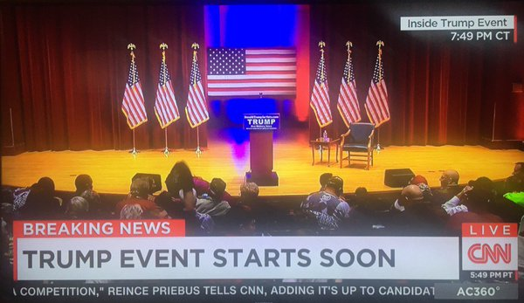
And the worst thing was that all the networks would do the same because their competitors were – often having an on-screen countdown clock to Trump’s arrival as their rolling pundits discussed his campaign with the seriousness that should have been accorded to a serious campaign. And despite any scrutiny or criticism, nothing seemed to stick.

To mix two literary references if I may -- for Trump it was definitely a case of the only thing worse than being talked about was not being talked about; while the media, of course, were amusing ourselves to death.

The networks were deferential to him because he was already an established -- that is to say, ratings-driving – TV figure – for example, he was allowed to call in to news shows that had previously required their guests to show up in person.

Meet The Press put an end to that practice after a few months, but maybe the worst offender was the MSNBC show “Morning Joe”, whose love-hate relationship with Trump fed the show’s ratings, even while media critics attacked the hosts for being too chummy with the candidate.

It got to a point where I remember tuning in one morning as Joe literally asked Trump “What’s today’s message then?”

Of course, a problem was that Trump was basically refusing to interact on live television with anyone who threatened him, so the beneficiaries were those who didn’t: often that has been Fox News figures like Bill O’Reilly and Sean Hannity.

The candidate and Morning Joe hosts would frequently get into public Twitter feuds over something said on the show, which helped extend the Trump message through the day on another media platform. But of course during the campaign they have been far from Trump’s only online foe – his targets have included his nicknamed GOP opponents and Crooked Hillary Clinton, as well as various world leaders and, even, The Pope.

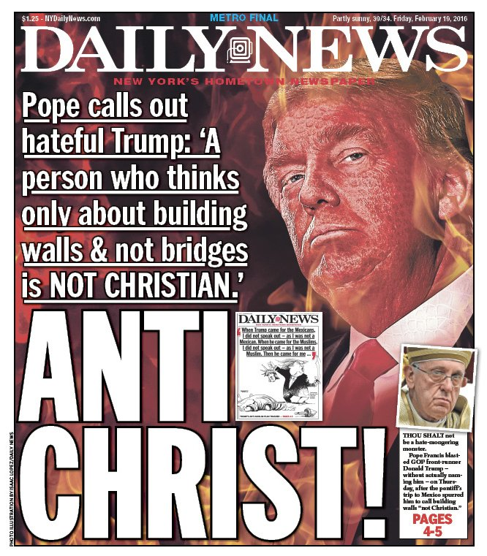

In fact, just on Monday, the New York Times published a double-page spread itemizing the 281 different people places and things Trump has had a Twitter row with. Not 281 instances, but 281 different targets.

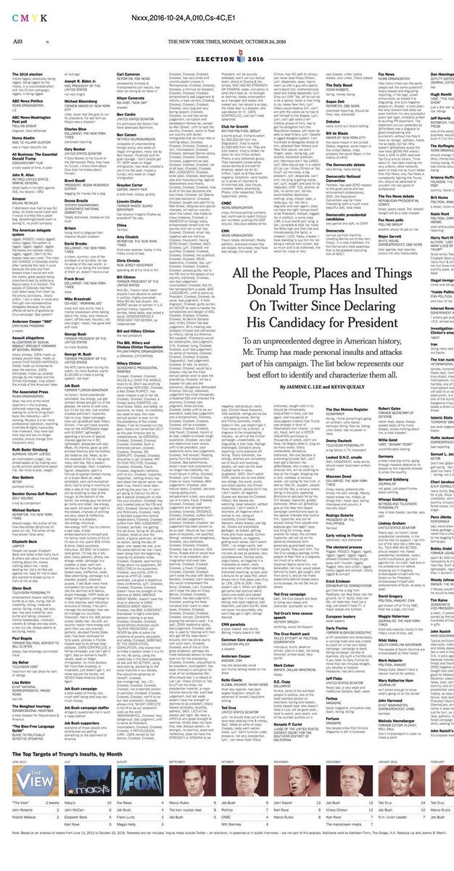

Yet Trump’s personal online temper has been nothing compared to the nastiness online replicated and extended by his army of social media trolls – recently self-identifying as “deplorables” after Clinton’s ill-advised description of them – who have not just reinforced Cass Sunstein’s idea of the echo chamber culture, but often pushed the boundaries of what is acceptable, attacking journalists online who are critical of their candidate in a way never seen before.

Election Night Twitter is going to be something else.

Overall, I think what we’ve witnessed over the past year and a half have been elements of the best and the worst of American campaign journalism.

Traditional horse-race coverage – the idea that candidates and campaigns have to conform to established parameters and do things the way they’ve always been done –
merely served to reinforce that media organizations and pundits have a huge vested interest in the very idea of a horse-race, and especially in a close one.

Except that this year one of the horses was actually a bull.

But somehow, that didn’t seem to matter – the press covered the bull as if it was a horse. And when it didn’t do things that horses do, pundits would say “well, that’s because it’s a bull.”

So the notions of a false equivalence – or “grading Trump on a curve” became accepted behavior both in media coverage and in how Trump’s supporters squared a political circle in choosing him over establishment politicians. Was he being judged by a different standard because he wasn’t a “politician”?
He was rarely pressed for detail, for example, on the practicalities of things he said – how exactly a muslim ban would work, or how and why is Mexico going to pay for a border wall.

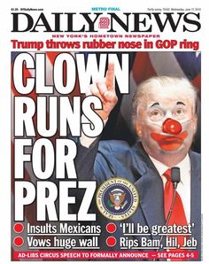

Even when Conservative pundits attacked him – the day after Trump entered the race, Charles Krauthammer said his campaign was based on “know-nothing xenophobia” – it simply allowed Trump to establish his credentials as an “outsider”, playing to his supporters’ perceptions of the Republican establishment as an elite that had little empathy with “ordinary people”.

After initially being dismissive of the seriousness of Trump’s campaign – and certainly elements of the press were slow to focus on exactly why he was resonating with certain groups of voters – as the primary campaign progressed the press was part of the show as Trump was able to sweep away an ineffectual Republican field that was spread so thin, one big personality was easily able to dominate it.

And it wasn’t just the Republican race he was dominating – studies showed that, for example, Trump was getting 23 times as much total media coverage as Bernie Sanders – a figure that rose to an astonishing 80 times as much when looking only at cable television.

In the general election, the fixation continued.

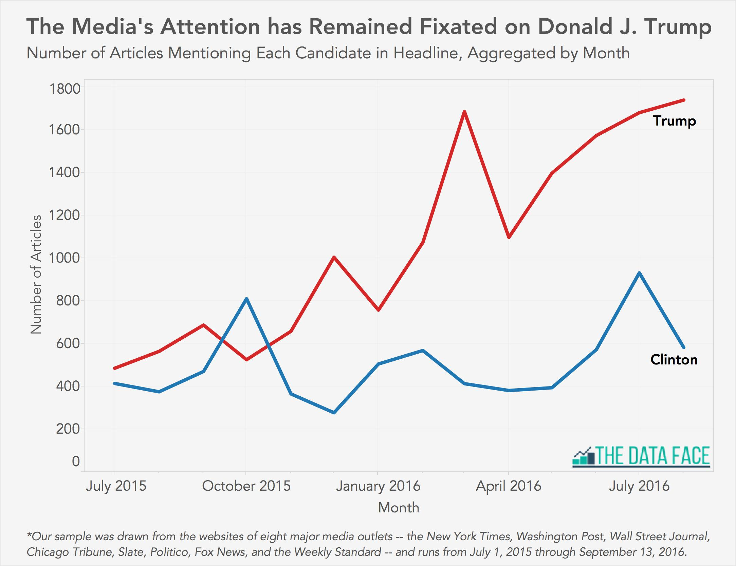

While thankfully I wasn’t a day-to-day beat reporter on this campaign, I have to pay tribute to those who were – who had to deal with unprecedented levels of personal abuse.

We always knew that come the general election Trump was going to fall back on the two hate figures he could hold up in front of his people:

Crooked Hillary Clinton, and the two-faced mainstream media.

But the treatment the press has received from Trump supporters as the campaign has drawn to its conclusion has been nothing less than shameful – and particularly so in the case of female reporters. Even to the point of being dangerous -

After once famously saying in an interview that he wasn’t like Vladimir Putin because -- “I won’t kill reporters. I hate them, but I won’t kill them” -- Trump regularly asks the crowds at his rallies to turn and look at the press pen while he castigates them for their bias and dishonesty – one target was NBC’s reporter Katy Tur, who subsequently needed a police escort from the building.

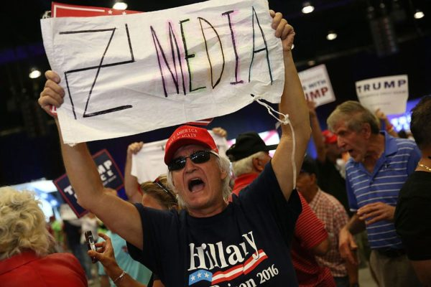

The latest trend at Trump events appears to be yelling “lugenpresse” – or “lying press” in German at correspondents, and taking their photographs. Many, many reporters have written about their unease while covering rallies.

But of course it’s dangerous to generalize and just yesterday, CBS reporter Sopan Deb tweeted a note he said was handed to reporters in the press pen at a rally in Tallahassee.

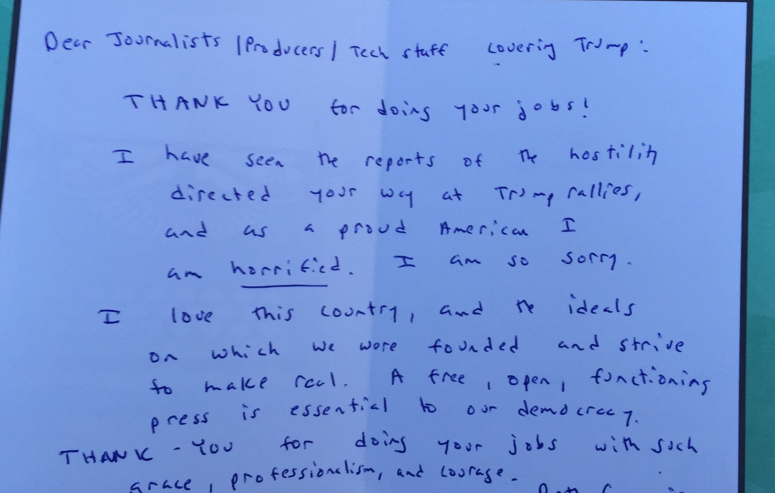

But the media has always been an easy target -

As Trump’s campaign appeared to be imploding in recent weeks, and when he accuses the media of being biased against him simply for writing down or filming what he actually says – he, and we, might tend to forget that without their giddy circulation-driven acquiescence during the primaries, he may not be where he is.
In a campaign full of “turning points” and what should have been turning points, I think what marked a shift in emphasis from the point of view of the media was a column in the New York Times by Nick Kristof in March in which he criticized journalists for being “lapdogs not watchdogs”

The article prompted a wave of self-examination – even self-flagellation – over the media’s complicity in Trump’s rise.

The Huffington Post, which famously decided in July 2015 to cover Trump’s primary campaign under the banner of its “entertainment” section, now runs this editor’s note at the end of every Trump story:

- Editor’s note: Donald Trump regularly incites political violence and is a serial liar, rampant xenophobe, racist, misogynist and birther who has repeatedly pledged to ban all Muslims — 1.6 billion members of an entire religion — from entering the U.S.

One of the things Kristof and others pointed to was the increased importance of fact-checking, alongside the acceptance that the unique nature of Trump’s campaign had almost rendered it irrelevant.

Some commentators referenced late night comedian Stephen Colbert, who in his guise as a right-wing talk show host had coined the term “truthiness” to mean the truth as felt in one’s heart and gut, rather than what might be found in “books.”

And certainly with a campaign driven around social media, the pressure to instantly react – to like or dislike something and vocally shout down anyone who tried to disagree – had become the new currency, rather than any balanced evaluation of fact.

As the general election campaign progressed, journalists, it seemed, were becoming increasingly desperate to scream to anyone that would listen that Trump was just making stuff up. At CNN, it was like someone was trapped in the control room and frantically signaling for help…

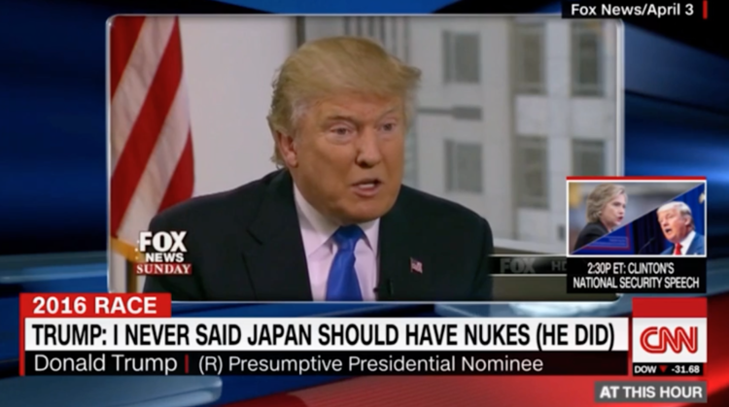

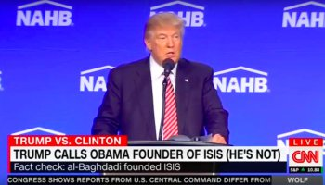
And probably my own favorite…

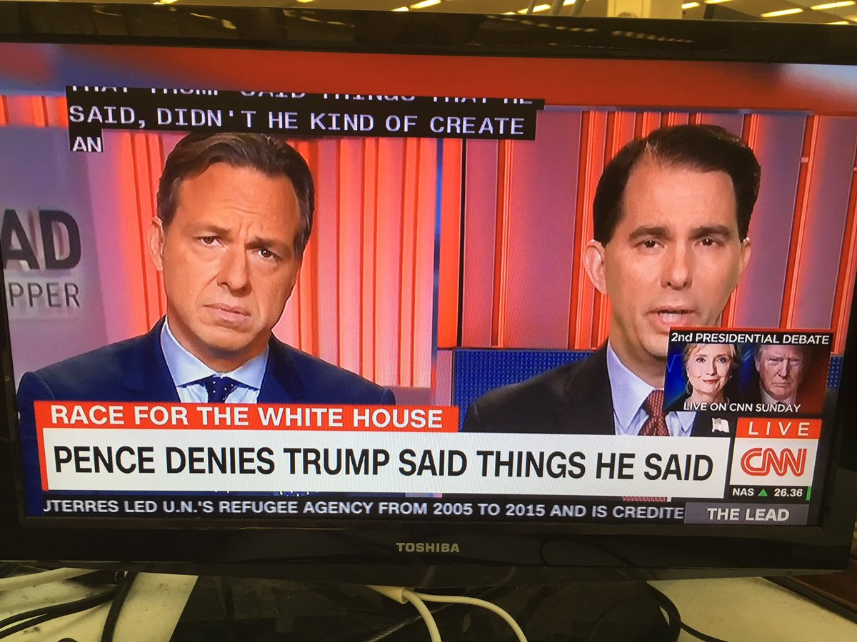

But there has also, I believe, been some of the best campaign journalism that we’ve seen for some years. The Washington Post’s David Fahrenthold, for example, did a huge amount of meticulous reporting on the activities of Trump’s charitable foundation – prompted by questions over Trump’s claims about his donations to veterans’ charities.

While Fahrenthold’s persistent and open-source reporting on the Foundation was important and led to action by the New York State Attorney General, it – as well as investigations of Trump’s taxes, which had dominated the time around the first debate – was completely overshadowed once the Access Hollywood tape emerged and the sexual misconduct allegations began.

It was almost the campaign in a microcosm – important work that would speak directly to the candidate’s accountability and credibility gets swamped by something more distracting – that in this case had a global audience.

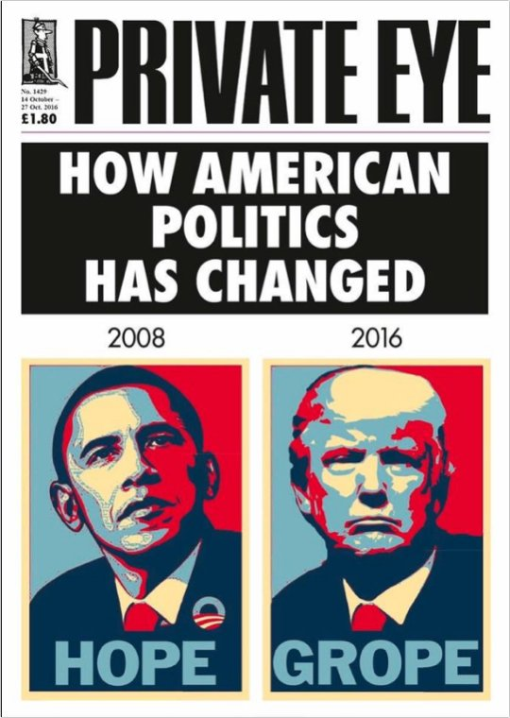
While newspaper endorsements really don’t mean as much as they used to the current tally is a good indicator of just how out of whack this race is compared with past contests
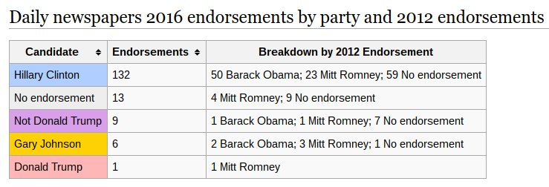

The reason I raised the issue of endorsements is that one of the defining pieces of journalism of this campaign appeared in the Arizona Republic – one of those papers to have endorsed Hillary Clinton – the first time in over a century it had supported a Democrat.

After receiving numerous threats, the paper’s publisher wrote an impassioned defence of free speech, connecting the anonymous threats to the very real people on her staff:

Here’s an extract:

“To those who said we should be shut down, burned down, who said they hoped we would cease to exist under a new presidential administration, I give you Nicole. She is our editor who directs the news staff, independent of our endorsements. After your threats, Nicole put on her press badge and walked with her reporters and photographers into the latest Donald Trump rally in Prescott Valley, Ariz. She stood as Trump encouraged his followers to heckle and boo and bully journalists. Then she came back to the newsroom to ensure our coverage was fair. Nicole knows free speech requires an open debate.”
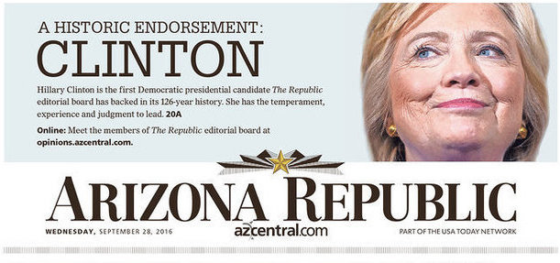

So where are we going?

Well if you believe the polls – and that’s probably a subject for a whole other seminar – here’s what some people might consider the “good news”:

In 12 days we’ll likely see a widespread repudiation of Trump and everything he has espoused in the past year and a half, which has largely destroyed as an effective opposition a Republican party that did not have the courage to stand up to him.

But that doesn’t mean we’ll see the end of Trumpism.

It seems unlikely that the man himself will go quietly. He never does anything quietly.

Preparations for Trump TV are well-advanced with disgraced former Fox News boss Roger Ailes likely heavily involved.

They gave it a dry run on Facebook Live during the third debate and it proved second only to ABC News for the most-watched coverage on that platform.

Having his own channel would perpetuate the concept of ‘politics as reality show’ and play into Trump’s attention-seeking celebrity personality, while providing a potential organisational focus for his supporters, many of whom no longer identify with the Republican party – if they ever did.

But there’s a fine line between galvanizing an audience in order to monetize them, and allowing them to project their own prejudices onto your rallying cry.

I mentioned earlier about “post-truth” meaning that this candidate’s words’ appear to be devoid of consequences – but there are increasingly, chilling instances where there is clearly a direct connection to the real lives of his supporters, who all too worryingly feel empowered – and feel also that their anger has somehow been legitimized.

This goes back to when Trump used to say at his rallies that he would pay the legal bills for anyone who got into a scuffle with a protester.

But just in the last two weeks – we’ve had instances of a Trump supporter who appeared to volunteer to “take out” Hillary Clinton in the name of “patriotism”; a law enforcement officer speaking at a Trump rally told the crowd it was time for “pitchforks and torches”, and a woman who told Mike Pence, Trump’s running mate, that she was “Ready for Revolution” if Clinton wins.

Pence’s response? “Oh no. Don’t say that…”

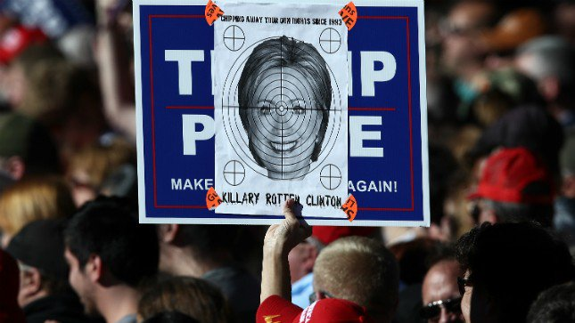

Regardless of the outcome of the election, there are real concerns for the nature of our civic discourse.

Trump has successfully brought extreme right-wing positions and conspiracy theories into the mainstream and given their advocates – like his campaign chief, the former Breitbart boss Steve Bannon – the kind of legitimacy they could have only dreamed of in the GOP of Poppy Bush.

But while what has happened - and what will happen - to journalism will be fascinating, and important; it is what happens to American society that will have the greater impact in the short- and medium-term.

It's important to understand this - particularly for anyone who might still see the Trump campaign as representing some kind of comedic performance art.

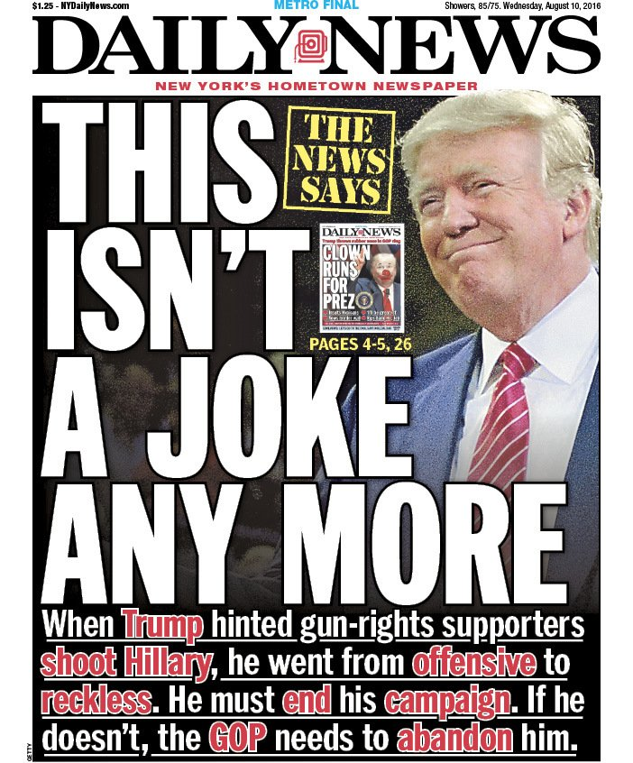

Truly - despite the NY Daily News front pages - it never was.

There is a significant section of the American populace who now feel more aggrieved, more alienated than ever – and the anger and viciousness that has been unleashed – particularly online, but also, unfortunately, in reality – is perhaps the most predictably un-American thing about all of this.

And even when Trump loses - *especially* when he loses – it will be a genuine challenge to our democracy to wind this back.

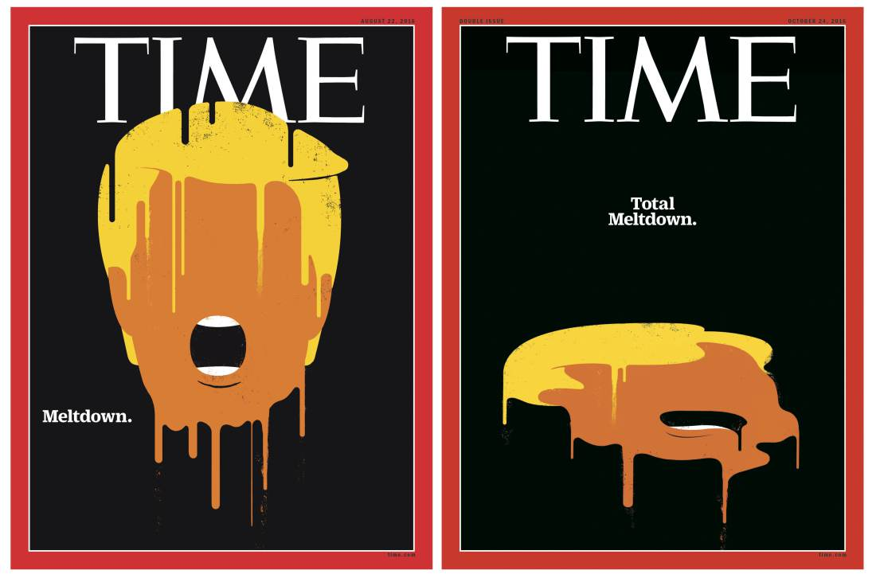

So more than ever we’re going to need a robust, dedicated, well-resourced press that can cast light on the reasons why America is so polarized, and why so many citizens feel left behind by a dysfunctional political system.

The media needs to ensure lessons are learned about what it got right and wrong about this campaign. After November 8th it will be important to break the co-dependency of day-to-day coverage, but at the same time continue to report on the forces that allowed Trump to flourish.

As well as, of course, performing the primary function of holding to account President Hillary Clinton and what could turn out to be an emboldened Democratic Congress.

